User Study:
Restarters.net
Findings report

An exploration of motivations, needs, and pain points for current and target users of Restarters.net
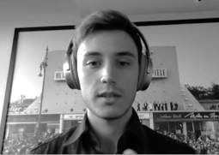 | 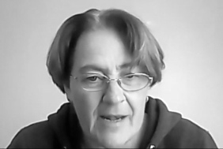 |  |  | 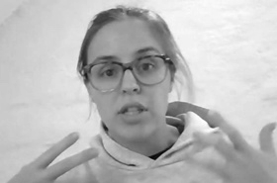

Users interviewed
Fernando (experienced host/ university)
James (experienced host)
Kaja (“superhost”)
Elias (new host/ “newbie”)
Stefania (repairer/ host)
Mel (“newbie” – registered user who isn’t deeply involved yet)
Jeannie (Director of Technology at school Restart programme)

Survey respondents

Main survey
- (Total countries/ regions uncertain, but at minimum: UK, Canada, Italy, Germany, Benin, Hong Kong, South/ Central America)
- 25 Hosts, 16 Repairers, 2 Activists, 11 Attendees

Follow-up for “newbies”
A 2-question survey was distributed to members who registered from countries where there are no groups, to determine their expectations of the platform.

Please consider all design recommendations that follow as preliminary, and for group discussion.

Summary of Findings and Recommendations
- The good: quite a few compliments for James’ support and Neil’s responsiveness to fixing bugs. A few users mentioned specific improvements to data entry.
- Interview respondents reported learning about The Restart Project through web searches, as well as local or international related events.
- Motivations are social as well as interest in repair and the overall cause. Hearing the story of an object and its owner, seeing the surprise and delight at the idea of repair, making new connections, as well as seeing a regular group of repair volunteers were cited as social benefits. One user expressed a competitive aspect to the repairing, however, at events where there are men; women’s events were seen by her as more cooperative. For schools, the story was quite inspiring: the enjoyment of being part of a group (“club” for children especially) and movement, adults and children learning together, forming new mental models of these objects as well as of ownership itself, setting up a positive environment for failure (“repair is just failing over and over again until you fix it”), and seeing the impact in decisions in the state legislature.
- Most challenging aspects overall were paperwork/ bureaucracy, being nervous about repairers showing up to events, having to turn people away at events when there aren’t enough repairers, and figuring out who to hand the hosting efforts off to when a host is ready to scale back involvement.
- Overall, the platform is seen as too “busy” (especially the Dashboard)—too many features and overwhelming pages, some unintuitive navigation. For example, every user who did a live walk-through with me clicked the Messages icon to get to Talk.

“When I log in, I freak out so much… so I just go to the top where it’s safe. Only three buttons.”

Design strategy recommendation:
Think about cutting as many features, content and UI as possible, and pushing less critical features and content to lower-level pages (that are still logically organised). Fix the global navigation so people can move between the three main sections more easily, and make it look like one site, not three (quite a few users mentioned that they weren’t sure if the sections were part of the same site).

- Hosts found the most value in Talk and the Fixometer (data entry/ stats)—despite the burden of entering the data. Data is always entered after the event; almost everyone uses a flipchart and takes it home to record later, sometimes weeks after the event. (Several hosts create events in retrospect just for entering data.)
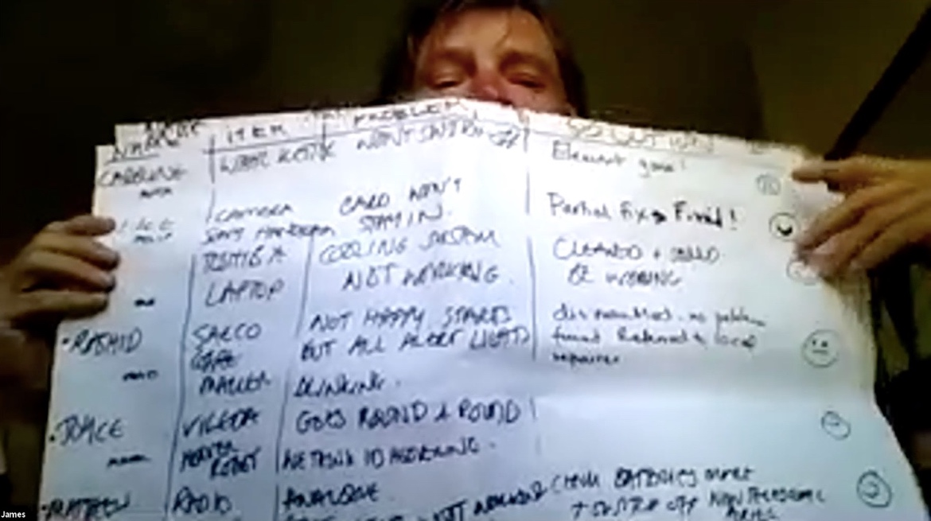

“Where’s the Fixometer… is it here [clicks Event page]? Is this the Fixometer [gestures at data stats]? See, the Fixometer is a very ambiguous concept… you know it exists, but it’s hard to define the boundaries of what it is and what it isn’t.” -Fernando

Additional points:

Once people figure out where the actual Fixometer data exists, they really like it. Several hosts are using the data stats to share with their funders/ boards, which is highly valuable to them. They seemed to really like the way the stats are displayed. Not all of them seemed to be aware of the ways to embed the data on their sites (note: this should always have a link back to The Restart Project, to drive traffic—not sure if it does now), or the Request Review feature. The U.S. user (Jeannie) mentioned wanting an Imperial system measurement option; currently she is using Photoshop to replace all the numbers herself before she shares them with her board. She also requested that “laptop large/ medium/ small” be defined, as she doesn’t know what these refer to, and they affect her stats. Also, model year seems to make more sense (even specific to Apple standards, like mid-2013) than age (could make this contextual to Mac laptops only if that’s a special use case.) Apple or Mac as prepopulated menu choice was confusing, and she wasn’t sure if the system was remembering her own choices or giving her system-provided options. Finally could the Fixometer data integrate with other carbon footprint tools? (Could help with driving traffic and add more excitement to this appreciated feature.)
Design strategy recommendation:
Prioritise these two areas and feature them on the Dashboard. Make the Fixometer data stats an easy-as-possible pathway to both review and creation—and make it really shine from page 1. Remove non-essential Dashboard content and reconsider the prominence and unintuitive organisation of Groups, Local Groups (in Talk) and Events.

- Talk was the most used general section, but also received the most UI and navigation complaints. It needs a bit of an overhaul, unfortunately, and I don’t list all the details around why here (but I can if there’s interest). The school-affiliated respondent (Jeannie) does not use Talk (and doesn’t think schools will), however. (Kids tend to want to use their own social media, and teachers have their own blogs and so forth; iFixit also has comments in context to repair instructions.) She is on Repair.org’s Slack and didn’t know Restarters.net had a weekly digest for Talk. Several users mentioned preferring the Google Group. Many users are accessing the platform via the e-mail digests, when they see a topic that interests them.

“I frequently have considerable difficulty returning to a post I saw a few days or weeks ago and I've spent ages trying to find a posting I received email notification about after deleting the email. And how to return to the root of the discussions tree isn't obvious. I never had any of these problems with the Google group.” - survey respondent

“The site is just too busy. It was better before when had the Google Group, easy to find what you wanted. Sometimes I look just to catch up on what’s happening–but there are too many heavy graphics.” - Stefania

Additional points:
Users do click through from the digests, which is an advantage to driving traffic to the platform. One newbie user even mentioned that the “e-mails make me feel like part of the group,” and liked that she “could reply from her e-mail” (I believe she meant directly link to the topic?).

Design strategy recommendation:
Consider whether Slack might be more useful than Talk; it’s commonly used now for a lot of online chat (even for grassroots orgs and nonprofits), and having channels by country and group would probably meet most hosts’ needs. An events channel could be used to pull in Restarters.net repair party event info., and people could create channel tag alerts for urgent messages, such as the need for repair volunteers last-minute. (However, you may want to check data ownership and privacy issues for Slack; I know the team feels strongly about these.) Otherwise, I would recommend a lot of UI tweaks to Discourse—so beware!

- The survey indicated hosts were less likely than other user types to cite ease of use on the platform as their main issue. The emphasis was more on the site lacking some key features for them, and other features are “overkill” (not needed and get in the way).
- Many hosts have separate organisations with platforms they manage and Restarters.net is mildly to very duplicative. One host mentioned that content and marketing (sites, podcasts, even Wiki) are best created within their country’s own context. Figuring out a strategy to maintain their own systems while being a part of the international community (the main advantage to them) is a key challenge for them. Could they integrate Restarters.net on their own site somehow for a smoother transition, one asked?

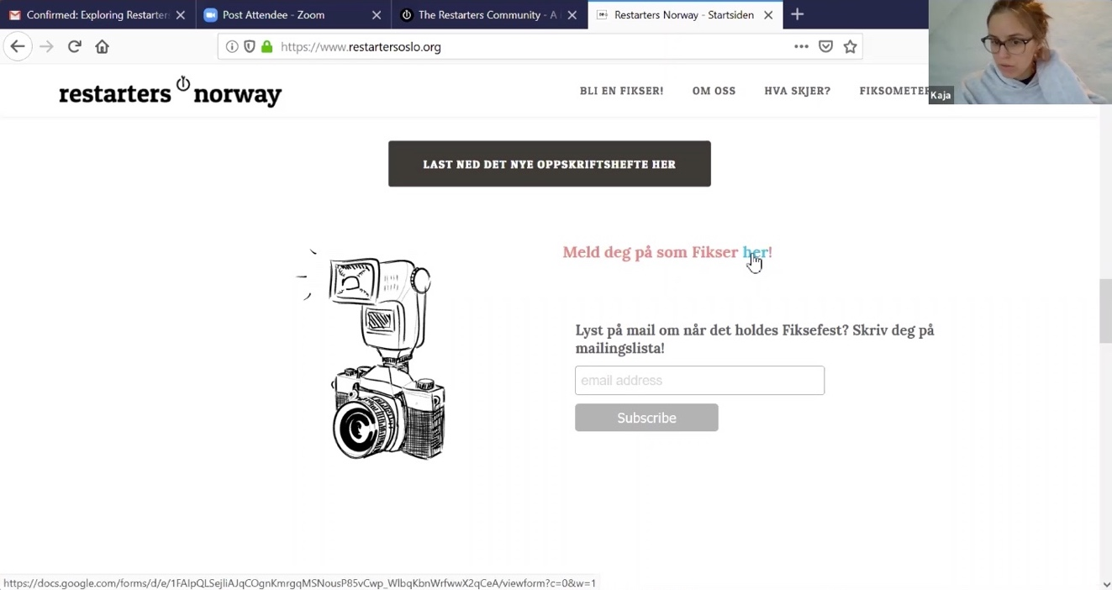
Kaja showing how repairers indicate their interest on the Restarters Norway home page
- Even though “being part of an international community” was expressed as a top motivation for being on the platform, not many users had specific ideas around what would be most useful ways to engage between countries, or what an international presence did for them. This is an area where some creative brainstorming should be done for ways to get groups to share and engage more.
Design strategy recommendation:
We should brainstorm, but the platform could really benefit from more pictures, blog integration, videos, and an easier way to see at a glance what groups are up to. One host mentioned wanting to see what groups are fixing, as repairers often specialise per group, and it might be interesting to mix groups. Also, consider listing groups from other organisations in your list, even if you have to link off-site to them; if your goal is to become a meta-site for grass-roots repair events, this would help more people feel they have more options. At the same time, make sure you express the advantages of the Restart platform; one user mentioned she registered because it was free (forever, and even for hosts) and not controlled by a big social media corp.
- One host is using helpful tools/ platforms such as https://www.notion.so/ (project management/ workspace) and https://waitwhile.com/ (booking/ waitlist tool). Most hosts use https://ifixit.com primarily for repair info.
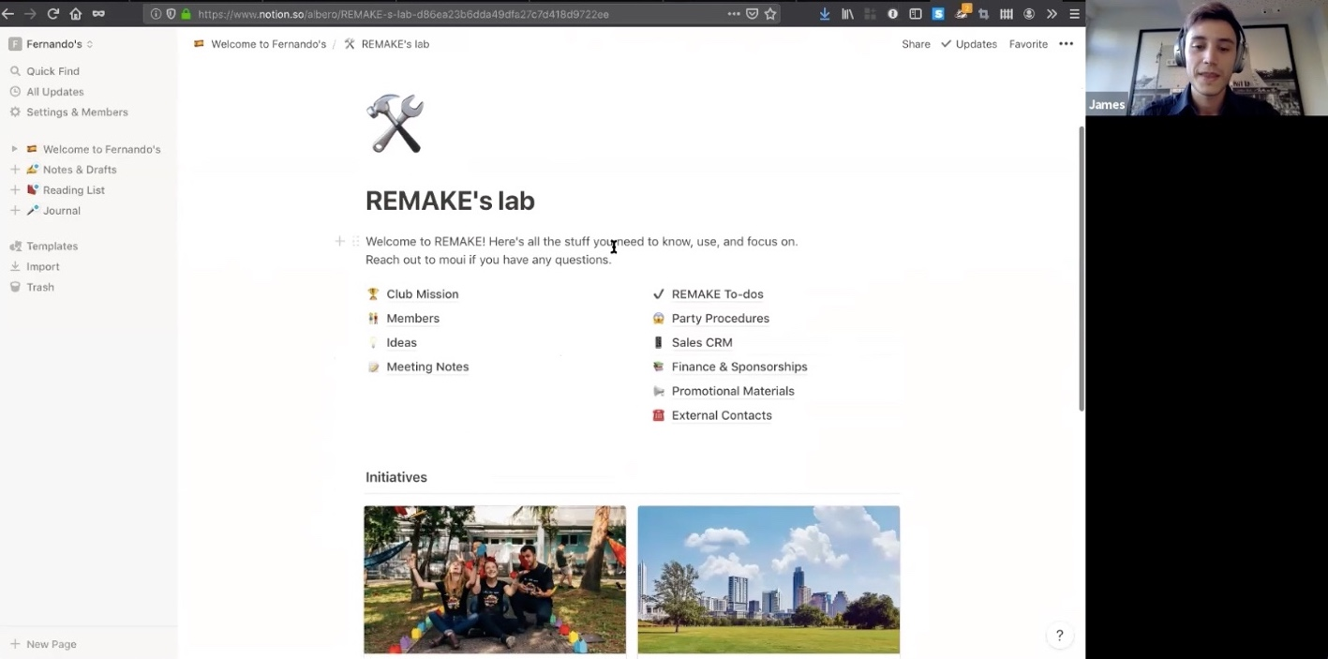
Notion.so – Fernando’s Dashboard
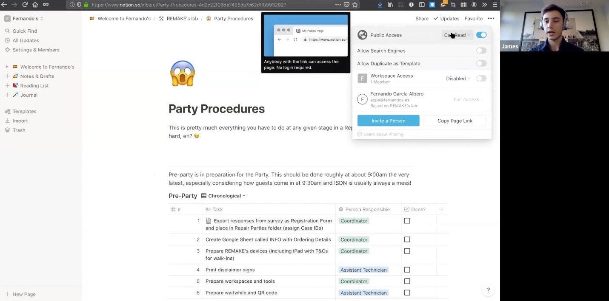
Notion.so – Fernando’s Shared Party Procedures
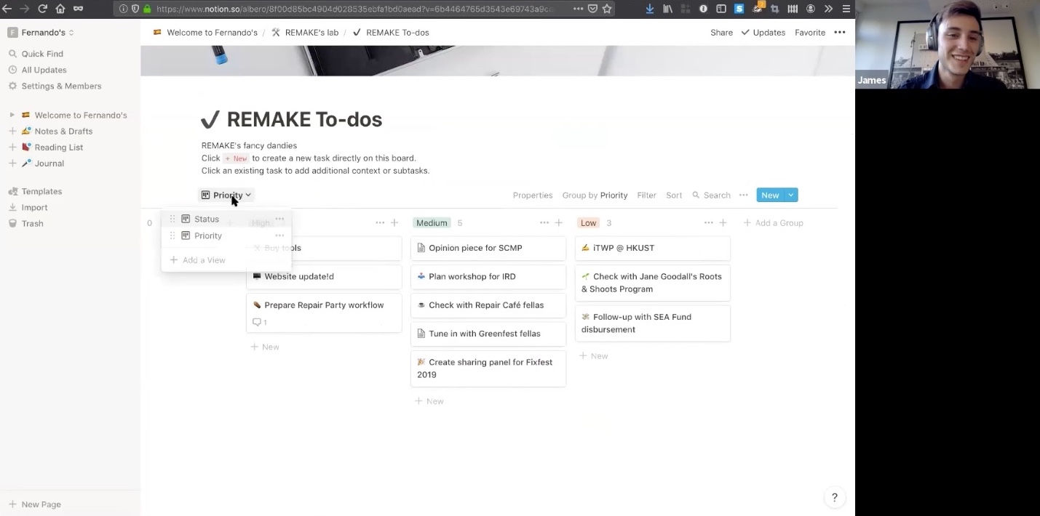
Notion.so – Fernando’s To-Dos

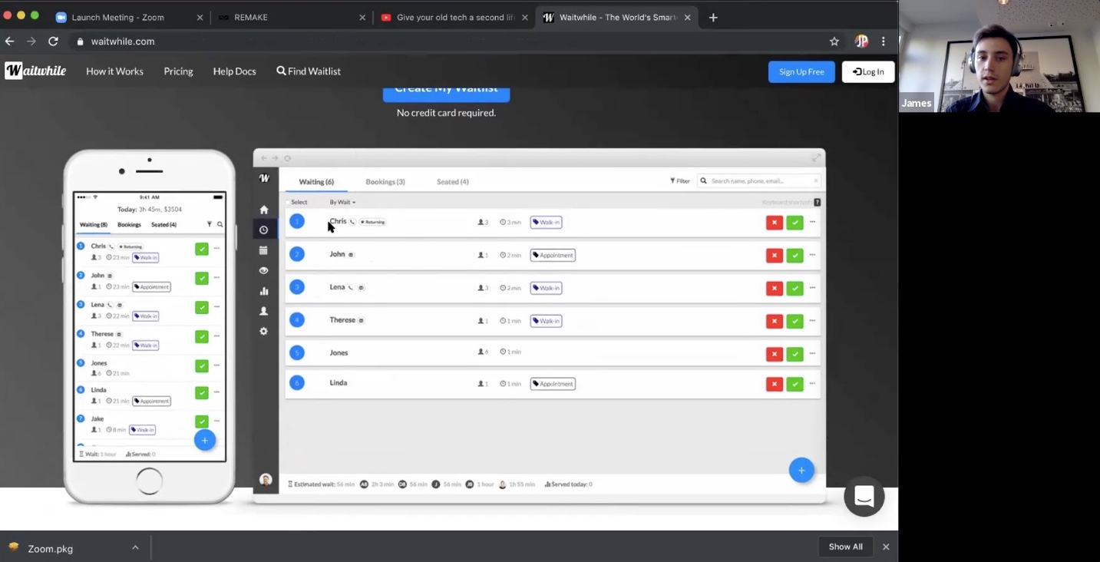
WaitWhile

Design strategy recommendation:
Consider suggesting these tools (and similar others) to users on the platform, and even asking Fernando (who uses the first two) to host a webinar. Users are asking for best practices, and these are great resources. It should be noted that several hosts mentioned people getting turned away at repair parties fairly often due to over-capacity/ not enough fixers; hosts struggle a bit with managing the people flow. Some host had strategies set up for bookings vs. walk-ins, bundling events for easier planning, and pairing events—for example, a diagnosing event, followed by ordering of parts, and then a fixing event. Two hosts also mentioned the attendee’s perception of their item’s problem is often different from the diagnosis. Tools like the ones above can help, and possibly adding additional fields for data entry to the Fixometer. What else might help solve the problem of people being turned away? Could there be a win-win in having people waiting sign up for Restarters.net (via a simpler registration path—also mentioned several times as a desired improvement in the survey) on their phones or a provided tablet to provide a path for repair alternatives, future events, and other goodies?
- Hosts had considerable worries about having enough repairers for events, and that the repairers understood and were adequately trained in the safety guidelines. James mentioned wanting volunteers to check a box online that they read and understand the safety guidelines. The newer host (Elias) requested in-person training and tools, if possible. Kaja mentioned she has a volunteer specifically to oversee safety at events.
Design strategy recommendation:
Open for discussion: various strategies to make hosts feel Restart is supporting hosts a bit better with safety needs. Consider a feature for an e-mail blast (or use Slack channel alert, as previously mentioned) if repairers are needed last minute; also consider the in-group, per event messaging support and automated reminders for repairers to confirm attendance. For cases like Elias’, could other members with the language skills to help out (Montreál?) help via video conference with Elias (assuming he can get the bandwidth; we did have trouble on our call with his connection)?
- We didn’t get a lot of data from repairers, but they seem to take a more casual interest in the platform; there’s nothing on the platform that’s all that critical for them, but they do help hosts a bit with data entry, and expressed some interested in sharing videos and specialised repair info., more friendly ways to edit the Wiki. (A few people expressed wanting more specialised repair tips as well, and member-provided information on techniques for tricky recent model repairs.)

“Apple keeps screwing things up in unusual way—it would be really helpful to know this right away.”
- Fernando

“Help me quickly find useful Data links for devices (eg. TomTom Rider1 GPS fix) or tutorials how to access and reprogram microprocessors inside household machines, for reuse of old Camera TFTs, or STL-data for spare parts.... This database is fundamental for repair and reuse.” - survey respondent

Design strategy recommendation:
This feedback correlates with what I suspected: repairers would probably really enjoy sharing useful repair content with one another, especially in a way that gets attention (not buried in the highly textual one-page Wiki). People enjoy how-to video content and many love to do their own videos (sometimes even silly—see YouTube!). There are opportunities here for fun ways to draw people closer and keep people engaged, and to provide late-breaking info. in a more promiment way.

- The Wiki wasn’t mentioned all that often, and seems to get limited use, but users did want it to be better organised and to invite more editing. It was seen as “tips and things” by the newbies; they would ask for specific advice on Talk.
Design strategy recommendation:
We know newbies and non-registered users are landing here, so consider a funneling/ conversion strategy for this section; but until you’re ready to let users add more interesting and dynamic content like videos and special repair tips for recent models, along with a more obvious way to edit this section and redo the layout, I would deprioritise improvements to the Wiki. I might also send people directly to iFixit for procedural content from here (as it’s excellent).
- Attendees/ newbies are mainly interested in finding groups near them or figuring out how to form them with others, and learning repair information (maybe even a mentoring programme).

Design strategy recommendation:
Create an experience for newbies that gives them a comfortable path to exploring the possibility of group creation and hosting. Our newbie interview respondent would have liked to have known if there were users nearby (even the next town over) and a way to have a casual chat with them about setting up a group. (Meetup has a feature where you can see how many people in your area have the same interest in a group, before a group is created.) Also, make the event planning kit for newbies more prominent (not buried in Talk), and more of a “kit” with downloadable goodies (such as template posters and such, not just logos), with a summary steps overview, rather than a five-post thread in Talk. Newbies should also be made aware that they don’t have to be repairers to get involved.

- As expected, not having groups nearby makes a significant “dent” in the experience, but hosts are also not that interested in browsing groups or events not their own. Groups and Events are actually only mildly useful without messaging functionality per group and group event, and seem to occupy too much space on the platform; local groups are also confusing.
A few hosts expressed wanting way to message their groups, per event, which seems like rather important, missing functionality.

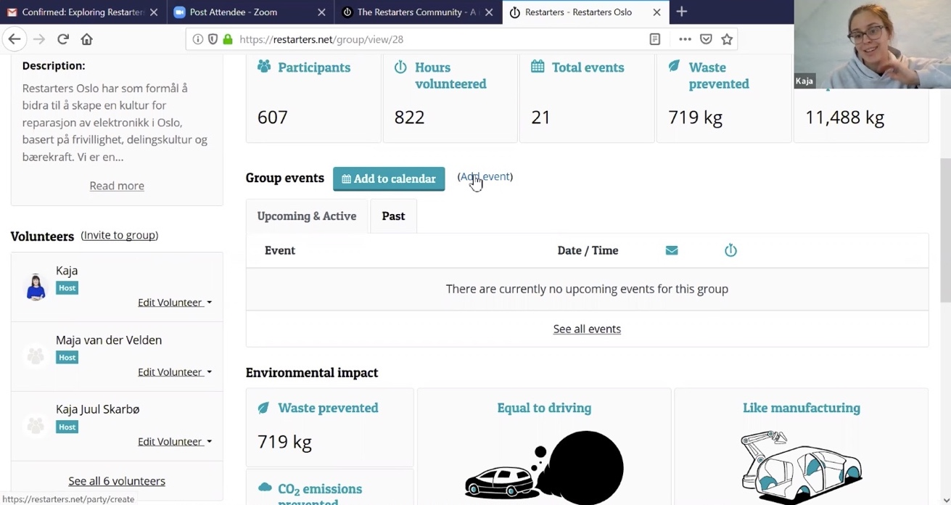
Usability note: going to a group’s page and searching for a tiny link in the midst of data stats doesn’t seem like the most obvious way to add an event. (And there doesn’t appear to be a way in the Events section.)

- One survey respondent mentioned that it’s not always clear which pages are visible to the public (there might be concerns around this; perhaps consider a “public page” label?)?
- It was difficult to engage activists in research (and therefore, the platform?), even through the survey. But they (and several others) expressed wanting to enter repair data outside of events.

Design strategy recommendation:
Because I just didn’t get much of a response from activists (the only two who answered the survey have never used the platform), I can’t represent users’ points of view here, but it seems a more robust messaging/ story strategy and letting people know more about what happens behind the scenes (Stefania suggested this) at Restart might be engaging to people. Jeannie mentioned Apple has recently introduced harder to repair products (as well as more expensive parts), which is a deterrent for the future of her school’s programme; this would seem to beg a story of your (and others’) growing movement of people wanting to repair being in direct opposition to this corporate trend. Also, perhaps integrating stories from “makers,” “re-users/ re-purposers,” and “minimalists” (even promoting films, such as The Boy Who Harnessed the Wind) and how they relate would tell a fuller story. And don’t forget to integrate a fully global point of view; for instance, Elias mentioned that the repair movement is new to Africa (although widespread reuse and repair most certainly are not), and he felt his community needed to be educated on the impacts of e-waste in particular.

- Not many users understand available preferences that can significantly affect the experience (such as language settings, frequency of e-mail digests, etc).
- There were several requests via the survey for (more) ways to enter non-electronic items.
- There were some complaints about getting logged out too often. It does seem like this is the kind of platform that doesn’t have many privacy issues, so a longer window before logout should be considered (as well as single sign-on and profile creation for all modules, as discussed previously, if possible).

- Event location was not registered correctly for the Hong Kong venue; Fernando couldn’t get the system to recognise the actual location.
- Hosts and repairers indicated they’re most interested in becoming organisers for school programmes, and all attendee survey respondents are interested in becoming repairers. About half of all repairers are interested in hosting.

Design strategy recommendation:
The school programme use case is so inspiring that even if school folks are not big users of the platform, consider making the pathway to getting a programme started more obvious. Note that I mentioned interest in doing this at the school of my nephew (a 17-year-old who is an avid fixer of all things, but especially electronics!), and Jeannie offered right away to talk to the Director of Technology at his school for me. I wouldn’t have guessed this was the right pathway to getting things moving, so it’s worth noting that this person (or whomever is in charge of tech at a school) is key in making a school programme happen. For attendees, making it clear that becoming a repairer isn’t the only way to get involved, as previously mentioned, might be key, but again, could there be a mentoring programme or clearer pathway to learning more, and how much one needs to know? And again, making an event planning kit more prominent and more like a kit would be helpful for those who might want to host.

- “Newbie” (users registered on the platform but not in countries with active groups—four respondents) expressed wanting to find out about nearby groups or just hear about repair events and gain skills in general.

Design strategy recommendation:
Definitely design for the newbie persona, if you want to motivate more people to get involved in different locations and create groups, but consider doing it in a way that doesn’t require skills selection to register (to streamline registration). There really is no obvious path for them now, and some research participants not based in the UK reported have a sense of being a bit “forgotten” or not closely linked to the organisation. Creating messaging and an environment that feels like you really want to expand globally is key here; otherwise, users will probably assume you just aren’t really ready for them.

Possible Next Steps for Design

Short term

If the remaining time for the shorter term design scope is firm, we should focus on the most meaningful small changes can be made in that timeframe. Below are key areas to think about and discuss. I believe I could handle the global nav and either Talk or Dashboard concepts in a week’s time. Global nav and a Talk revision might be the best short-term fix that buys a fair chunk of relief from usability issues.
- Global nav
While it is critical to fix the global navigation problems, keep in mind that larger changes to the key functions and content of the site will affect changes here. Also, technically, we need to be sure we can build a consistent nav bar—including nav items, look and feel—across all the modules. Neil should confirm.

- Talk
It’s not controversial to keep some sort of forum or chat function at the center of your digital strategy, no matter which other changes you may decide to make. From the research, I’m proposing that the first decision might be whether to keep Discourse or use something like Slack or other group communication tools. The e-mail digest does work to keep users returning, but lots of people use Slack now, and it has the advantage of being a mobile app with notification features for the phone (for those urgent last-minute repair volunteer requests, for example). Part of the consideration might involve pricing and/ or data privacy concerns. But also, our ability, technically, to drastically change the UI in Discourse should be weighed. Most the changes needed include eliminating some navigation, using Categories more strategically and changing the names to be more intuitive, creating a Category per actual repair group (and teaching users to chat with their groups about events here, and fixing the inconsistent sub-navigation. For instance, from the “Categories” page, to the Local Groups page to the Messages page—all the sub-nav should be the same so users can navigate between all of these. While we’re changing things for Talk (if we do), it might be nice to bring the user’s photo from the Dashboard side to here instead of making them upload a new photo. The look and feel of Talk would need to change drastically to match Dashboard, and I might even eliminate the theming capabilities in the preferences so users can’t accidently change look and feel. Again, I’d recommend a call to action to make sure users are signed up to get the digests here (as well as on the Dashboard).

- Dashboard
Dashboards and Home pages are often more controversial and need more creative concepting. But instead of revising Talk, I could create some more inviting concepts using only the current content at maximum, with the exception of possibly add a section under the topics for topics users have replied to (if technically possible), as this was mentioned a few times as difficult to find.

Longer term

For the longer term, I suggest sitting with this research a bit more, perhaps talking with a few activists on your own as well; then, taking a more strategic approach that includes a review of prioritised goals and the development of personas and use case scenarios that more accurately reflect how various users might want to experience the platform. There is certainly a big difference between hosts and newbies, for example. Hosts and repairers have different needs as well, and of course, location is also an important aspect of the experience. The highly variable needs and expectations of these user types make improving even basic features such as Events, Groups, the Dashboard, and the Fixometer more complex than it may seem at first.

It’s worth reiterating the few “red flags” the research uncovered (as I see them), even if some don’t directly relate to the platform as it exists:

People are getting turned away from repair events that don’t have enough repair volunteers, and it sounds like this has happened fairly often, even at an experienced host’s event with seven repairers present (the complexity of the repairs was difficult on this particular day). Though hosts didn’t dwell on the issue in our discussions, I could see the problem being a bit damaging to the movement and brand/ reputation if it happens often. I’m also not really sure how the parts ordering works outside the school/ university environment, as community hosts didn’t discuss that. Either having more frequent events or incorporating a booking system and paired events (diagnose/ fix) like Fernando’s seems to minimise the overflow problem, but in lieu of these, again, I might want the platform provide a path to future priority, perhaps, for people who can’t be seen at events.
- I was a bit surprised by the tension—even if slight—between keeping separate group efforts going digitally, and integrating with The Restart Project, particularly where countries were concerned. Kaja, for example, really seemed to think marketing to Norwegians was best done separately; however, she saw great value in the Fixometer stats and possible value in using the Talk feature for the Norwegian community. Fernando’s highest hope was that Restarters.net could be used for his project management functions, in place of Notion—otherwise, I don’t think he is all that interested in the platform. I think some effort will need to be put into drawing international users into the platform—especially as some hosts aren’t even advertising their events there—as well as creating a more global/ international feel. Several users mentioned that it’s much easier to look for events on one public page on therestartproject.org.

- The newbie path needs to be carefully considered, as—like users outside the UK—the site doesn’t quite feel like it’s meant for them. Perhaps there needs to be a “light” version of the site for them. And, perhaps, there could be calls-to-action to add host, repairer, activist, or school program features, as appropriate after registration, rather than basing the whole experience around the skillset you select as you register (and then forget about). Providing a real pathway into each of these roles should also be considered.

- Finally, I was a bit surprised the data entry was usually first done on a flip chart, and I thought the complaints about the data entry would have been much greater overall (though there were several). However, I wonder why no one has asked for a way for party attendees to enter their data as part of their registration/ check-in on an iPad or phone. There would certainly be plenty of time for that, it shouldn’t be too prone to user error, with some support, and it’s not a lot to ask in exchange for free repair help. I think the flip chart’s presence in the room must be important (although Fernando uses a projector/ screen), but hosts could copy the important bits of the data to a flip chart. Certainly, the digitised data entry by attendees would save them a lot of time: they would only need to enter the diagnosis/ solution later. In any case, as the Fixometer is really your proprietary feature, I would review every aspect of it, including how you’re promoting it, to make the use of it as graceful and compelling as possible.

While I think further analysis, creativity and openness (OK, as well as budget!) will be needed to maximize the effectiveness of the Restarters.net platform, there are lots of ways to use digital media to help address the current challenges and increase engagement overall with The Restart Project!

